**Supplementary figures**

**S.F.2, A-F.** Boxplots of biostimulation of potato plants treated with P. oligandrum (blue boxplots) or untreated controls (red boxplots), in the three different genotypes Kuras, Desirée, King Edward, in greenhouse bioassays. (**A-C**), logarithmic transformation of dry weight of the potato shoots in grams at the end of the experiment. A, cv. Kuras and B, cv. Desiree and C, King Edward. (D-F), square root transformed dry weight of roots of the potato roots. In D, cv. Kuras and E, cv. Desiree and F, King Edward. The potato plants were either untreated control plants or treated with P. oligandrum. Significant difference (p < 0.05) is indicated with an asterisk. The total number of plants used per treatment was n=6. The experiment was repeated three individual times.

**S.F. 3 A-D**. Temporal change in mean relative abundance of top 10 Bacteria (A & B) and fungal phyla (C & D). Different letters indicate significant difference detected with one way ANOVA with significance accepted if (p < 0.05).

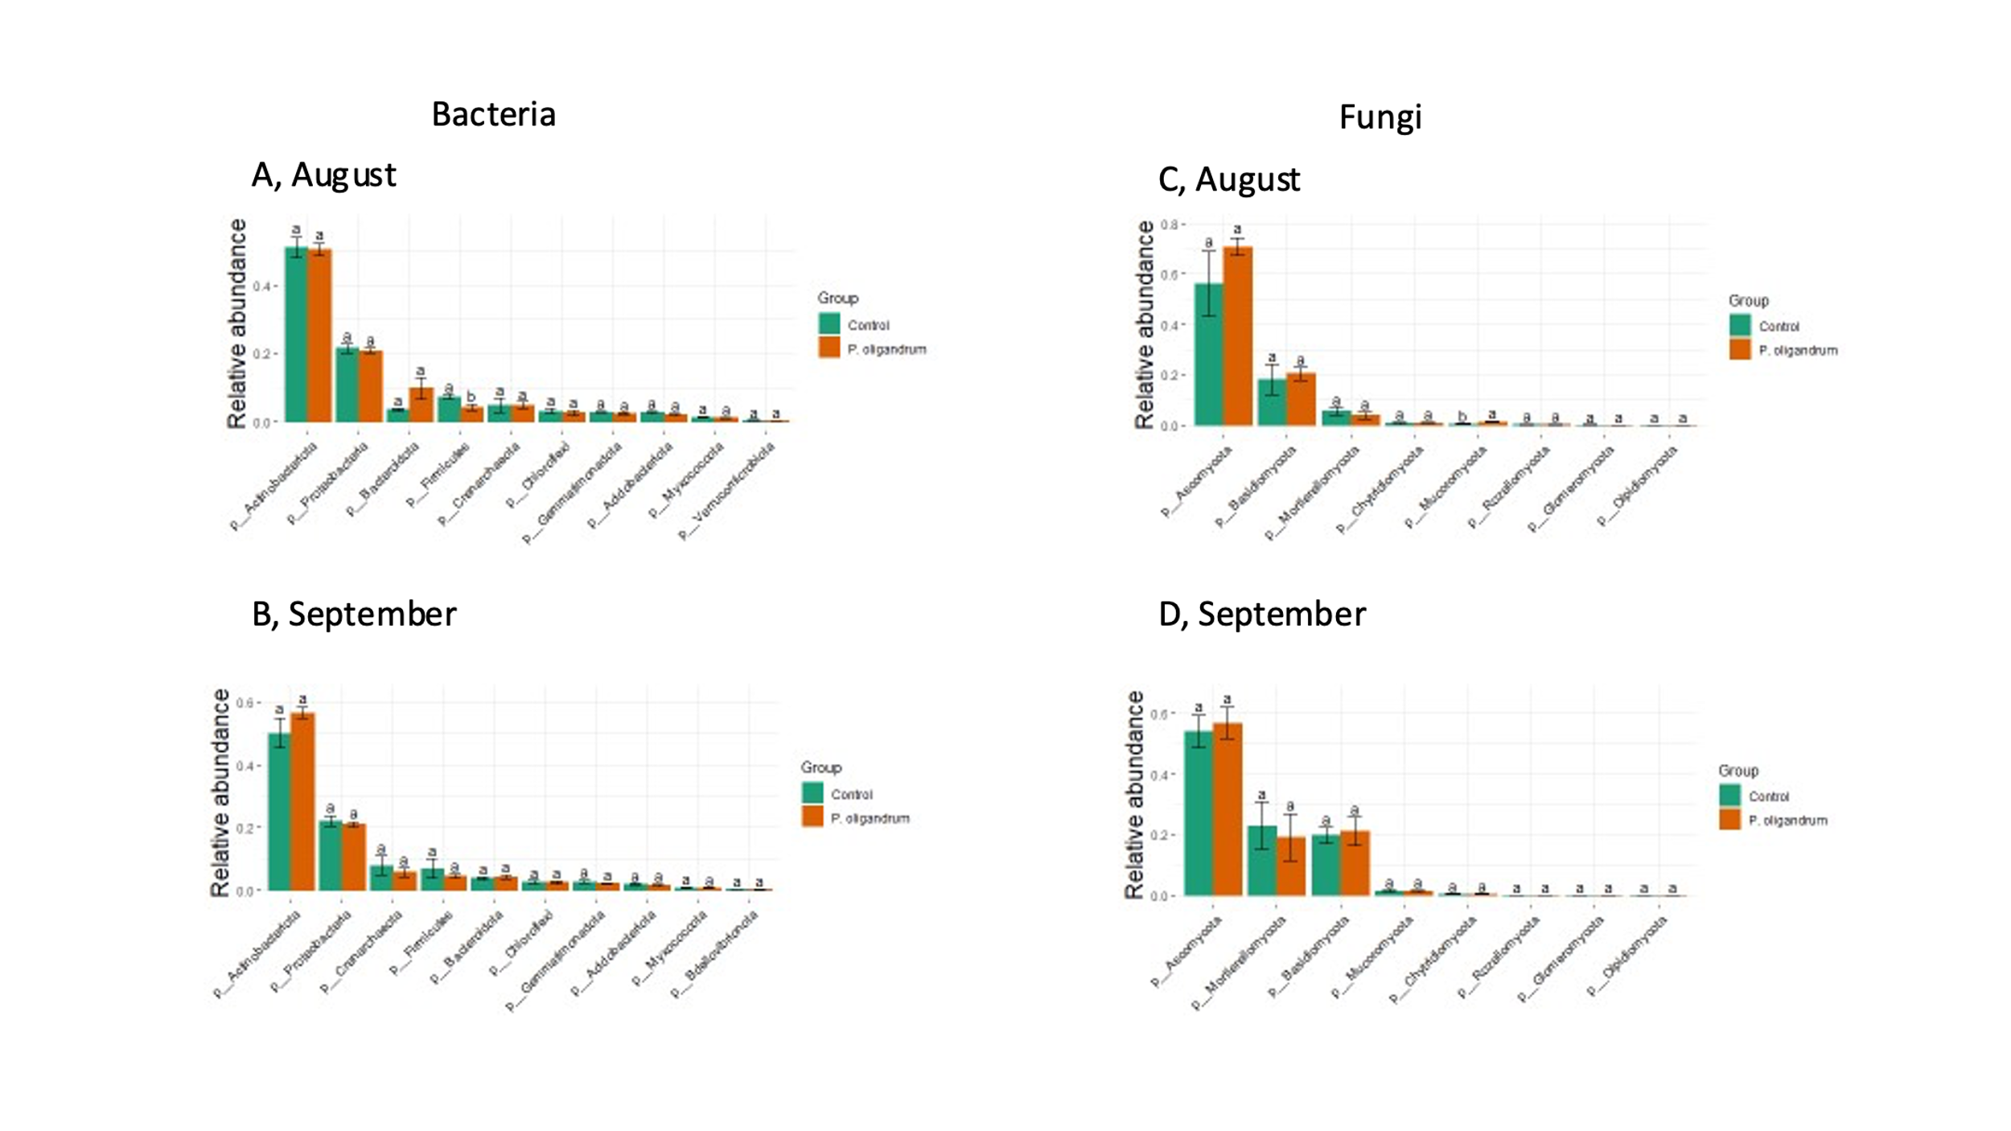

**S. F. 4, A-D**. Comparison of the relative abundance of top 8 bacteria and fungal phyla between untreated control plants and P. oligandrum treated plants in the rhizosphere microbiome of cv. Kuras potato plants in a small-scale field trial**.** (**A**) and (**C**) at the August timepoint and (**B**) and (**D**) in September. letters indicate significant difference detected with one way ANOVA with significance accepted if (p < 0.05).